Write a program for swap two numbers

#include <stdio.h>

int main()

{

int a, b, t;

printf("Enter two integers\n");

scanf("%d%d", &a, &b);

printf("Before Swapping\nFirst integer = %d\nSecond integer = %d\n", a, b);

t = a;

a = b;

b = t;

printf("After Swapping\nFirst integer = %d\nSecond integer = %d\n", a, b);

return 0;

}

OUTPUT

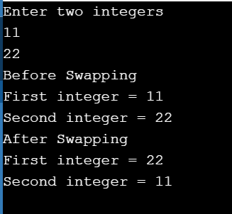

Write a program for even or odd

#include <stdio.h>

int main()

{

int n;

printf("Enter an integer\n");

scanf("%d", &n);

if (n%2 == 0)

printf("Even\n");

else

printf("Odd\n");

return 0;

}

OUTPUT

